Moonlite Software installation /Driver installation/ and troubleshooting guide

Section 1 - MoonLite USB FTDIChip Driver Installation Guide

Section 2- Moonlite Non-ASCOM Software Installation Guide

Section 3- Moonlite Software Troubleshooting Guide

Section 4- ASCOM Driver Installation Guide and hardware notes

Section 5- The SKYX Plugin

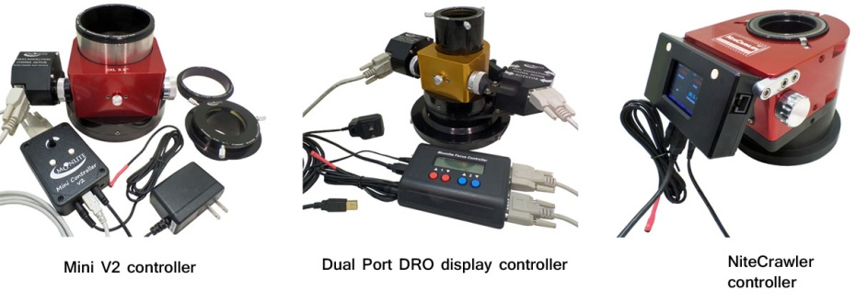

Moonlite USB FTDIChip driver installation

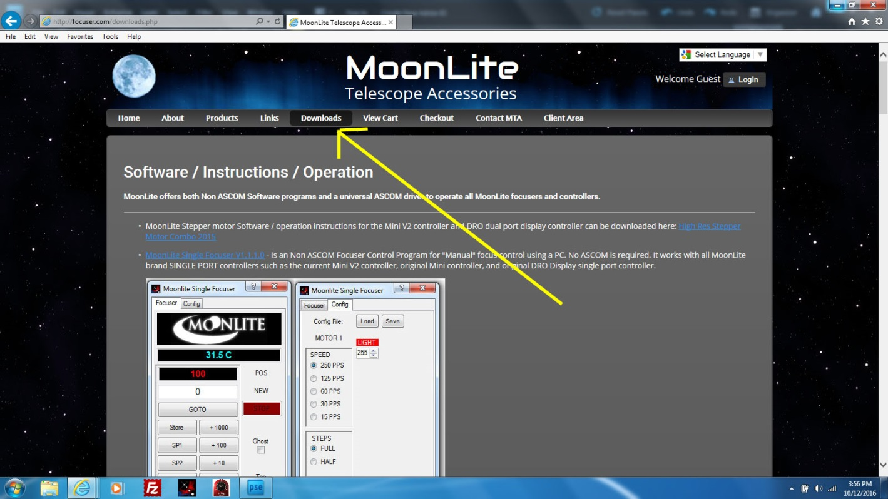

All MoonLite controllers and focusers use the USB FTDIChip driver. Be sure to download and install the FTDIChip driver in your PC before trying to connect to the focuser’s USB port. Click on the Download Tab on the MoonLite page for the link to the USB driver and all other software downloads.

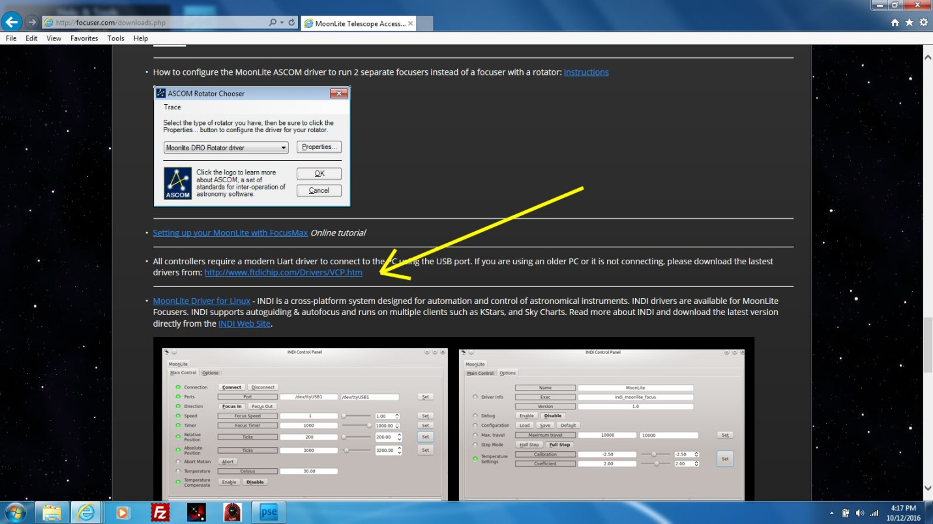

Click on the link to go to the FTDIChip software page.

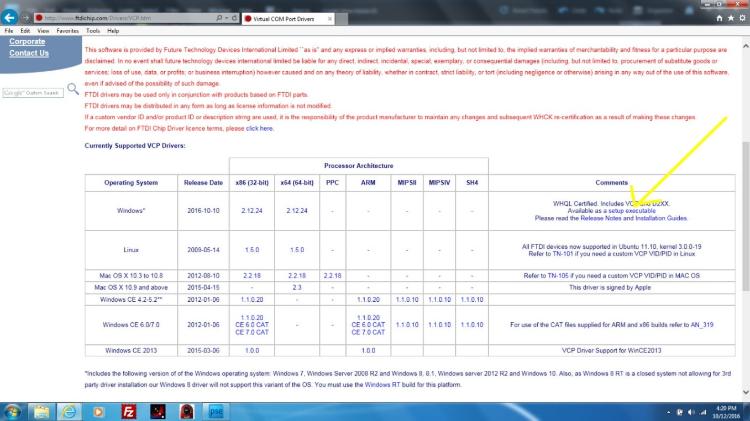

Click on Setup Executable.

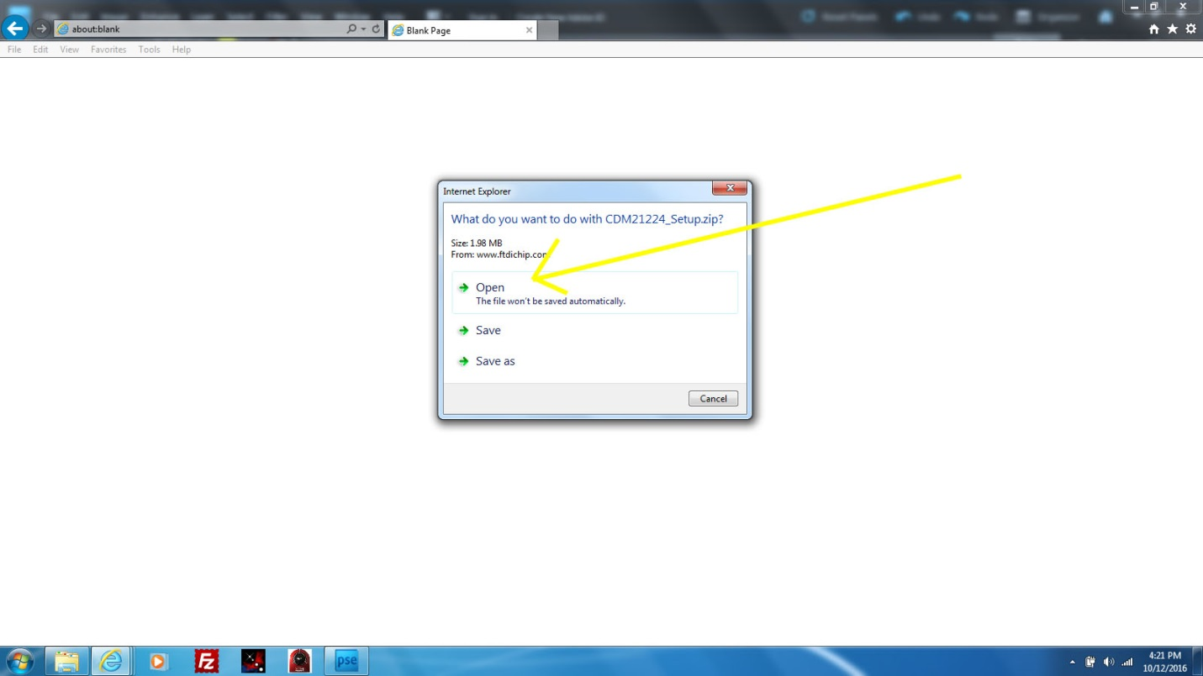

Click Open. Bottom of screen will show Downloading.

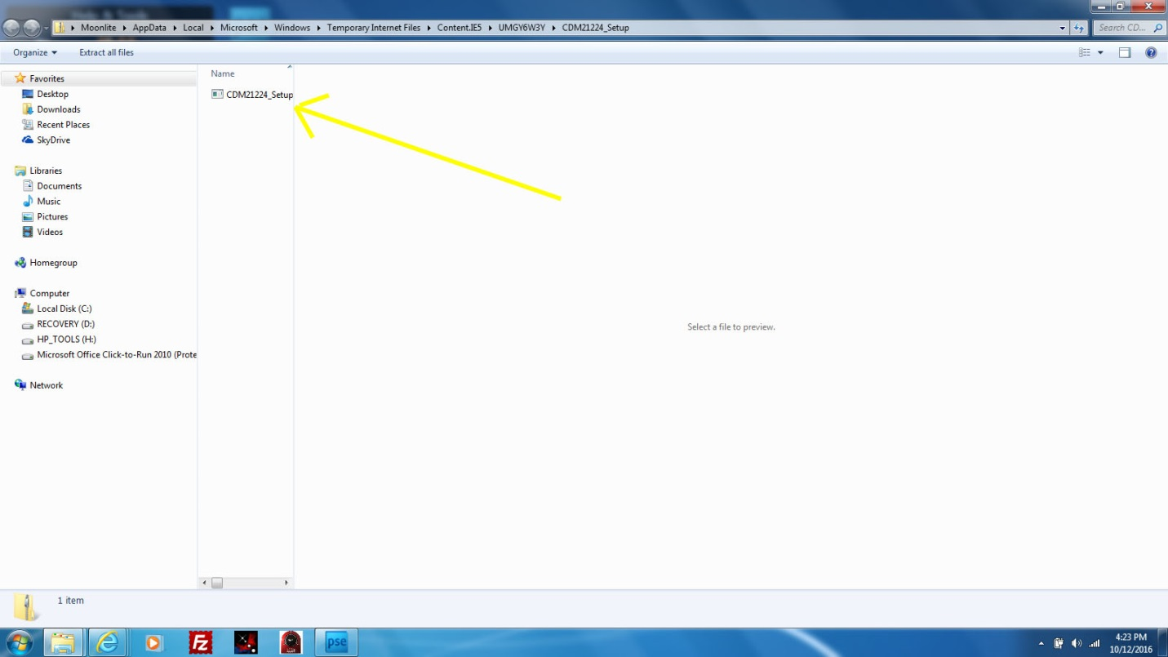

Click Setup.

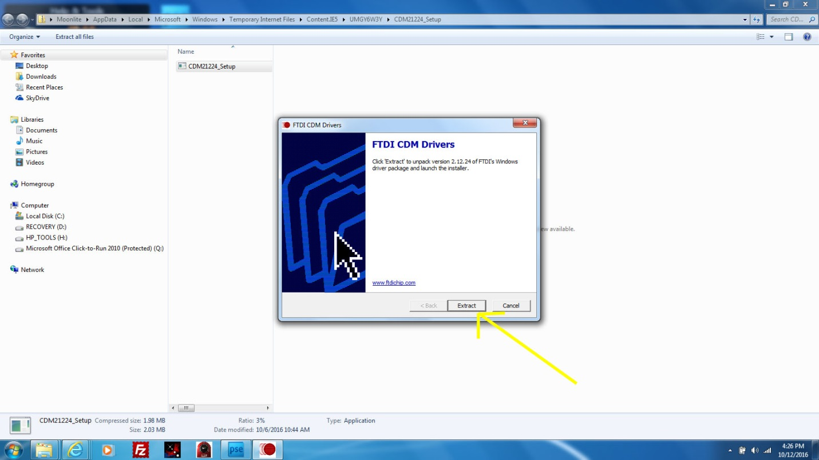

Click Extract, then Next

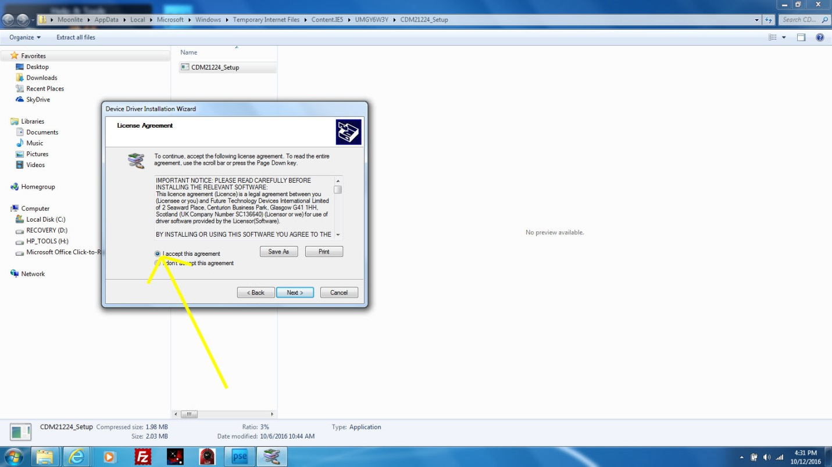

Check I accept, then click next.

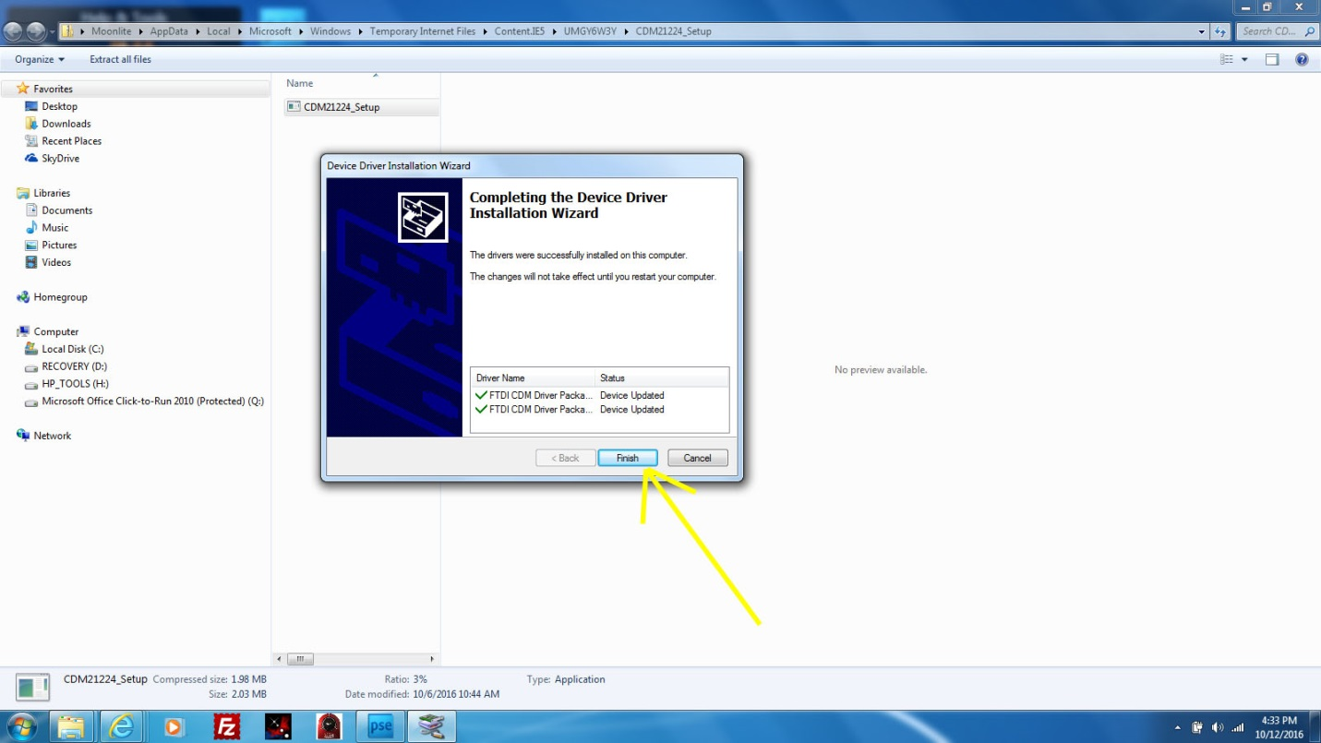

Click Finish.

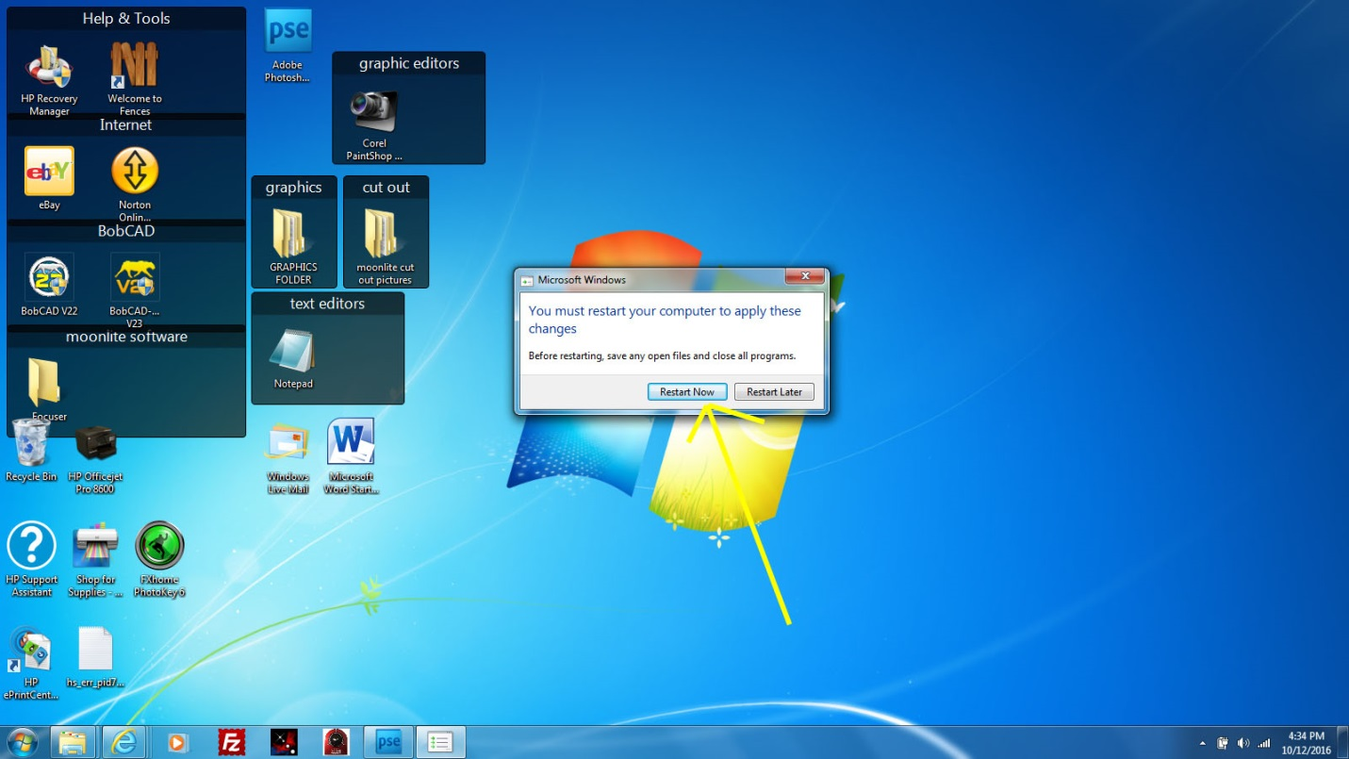

Reboot your PC so the drivers will be active.

MoonLite NON-ASCOM Software Installation Guide

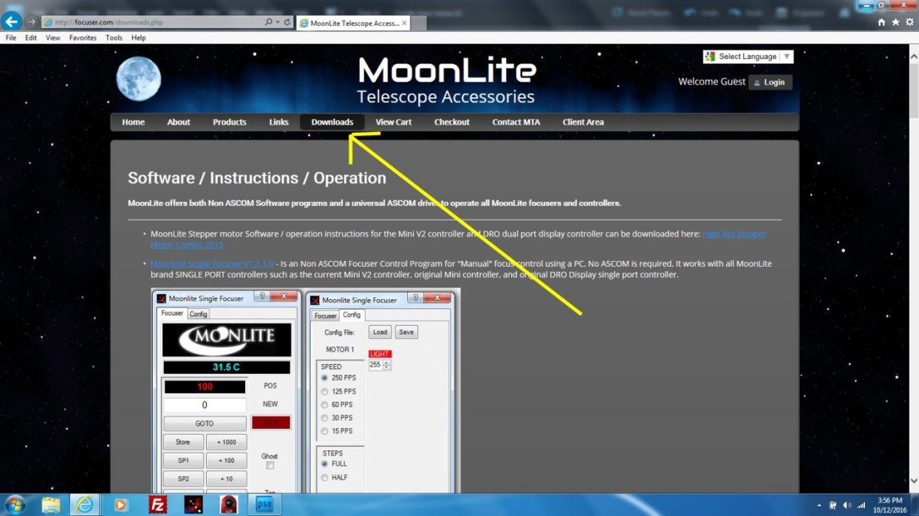

All MoonLite software and drivers are located under the Download Tab at [www.focuser.com](http://www.focuser.com) .Click on Downloads to see all options.

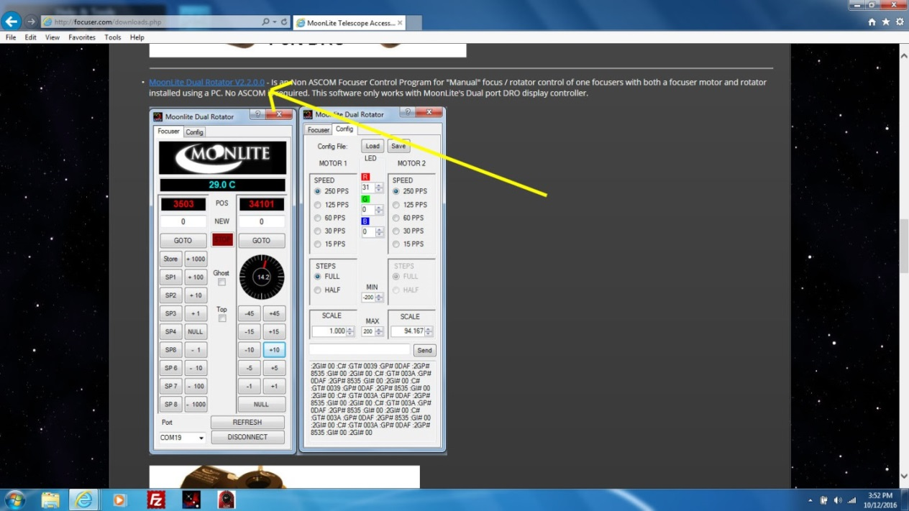

Click on one of the software programs. In this example, we will be installing the Dual Rotator Software for a focuser running the dual port controller with both focus and a rotator motor.

Click on the link to start the process.

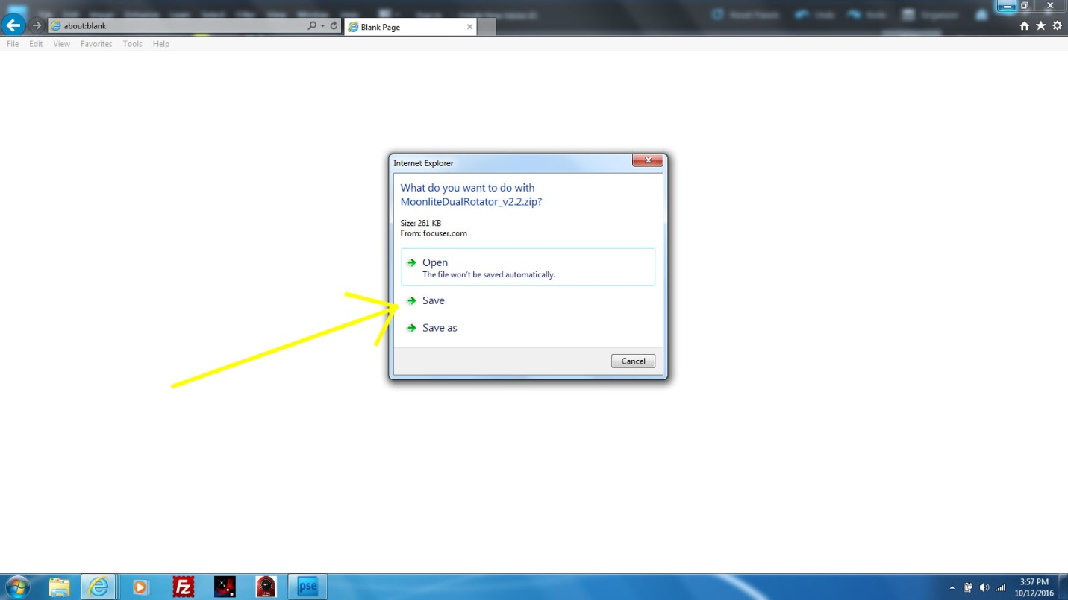

Click Save.

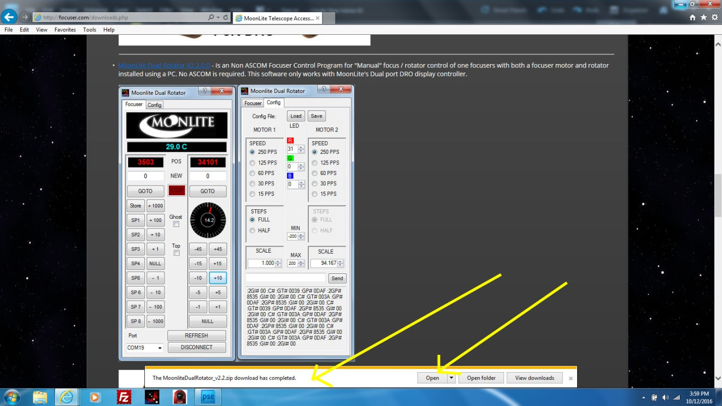

Click open after it completes the download.

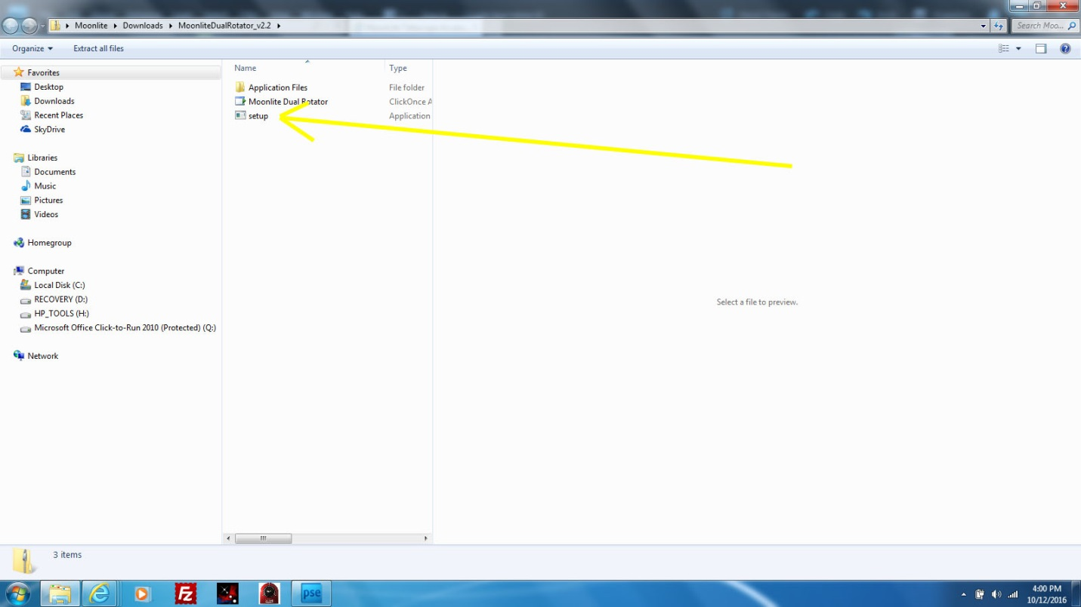

Click Setup to start installing it.

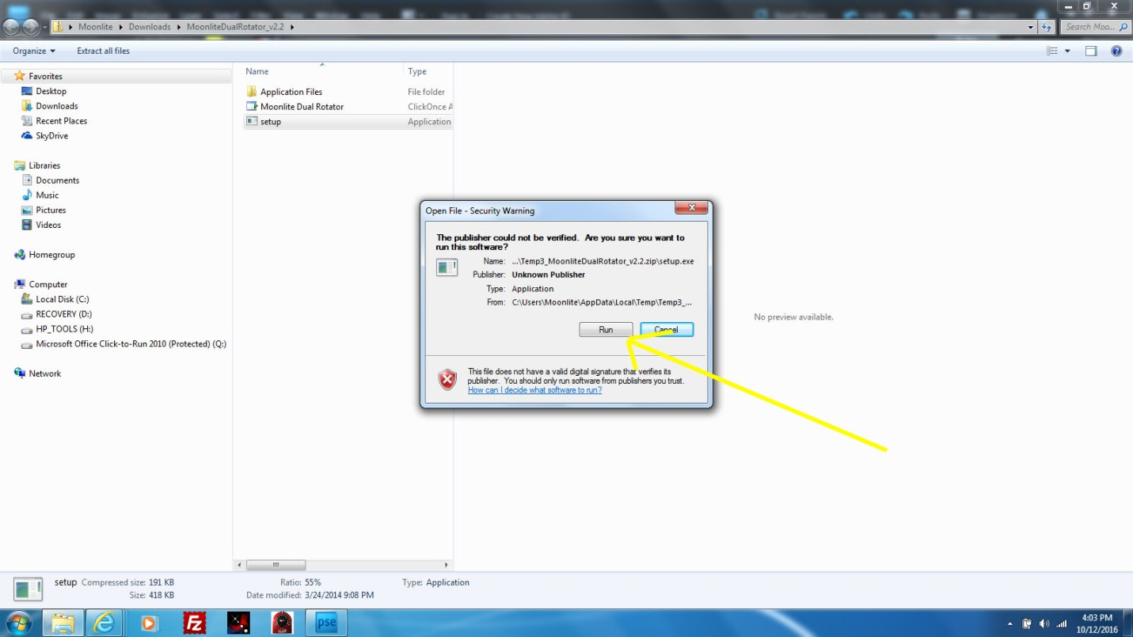

Click Run to install.

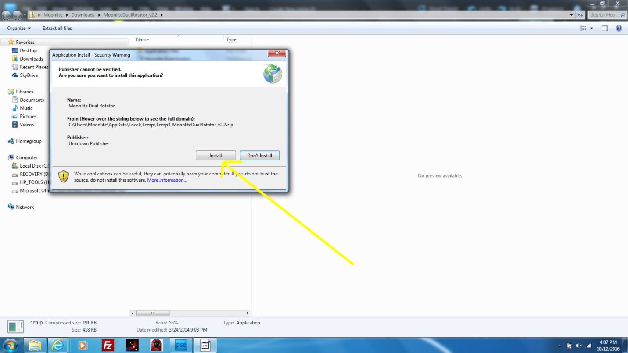

Click on Install.

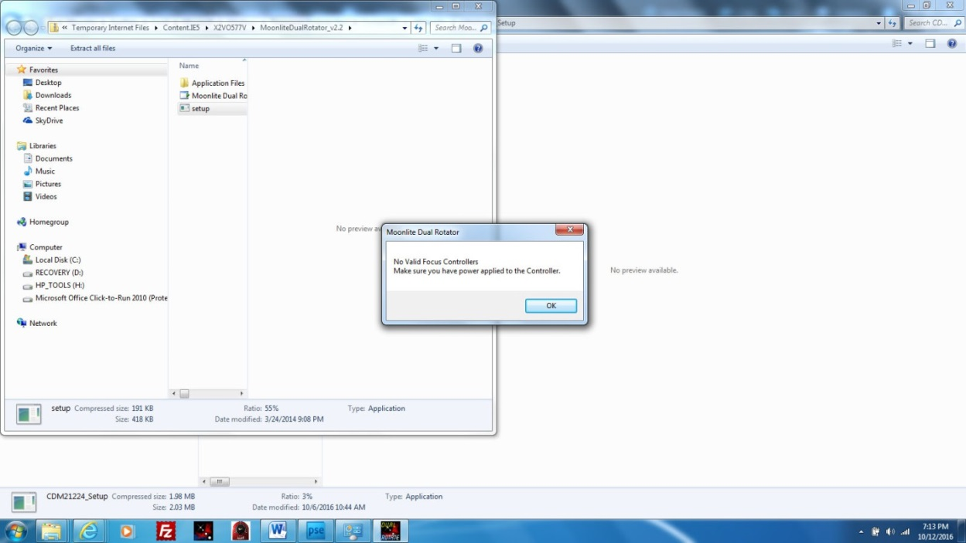

The software will try and launch; however, you may see this error if the controller is turned off, not plugged in, or if the USB driver is not installed yet.

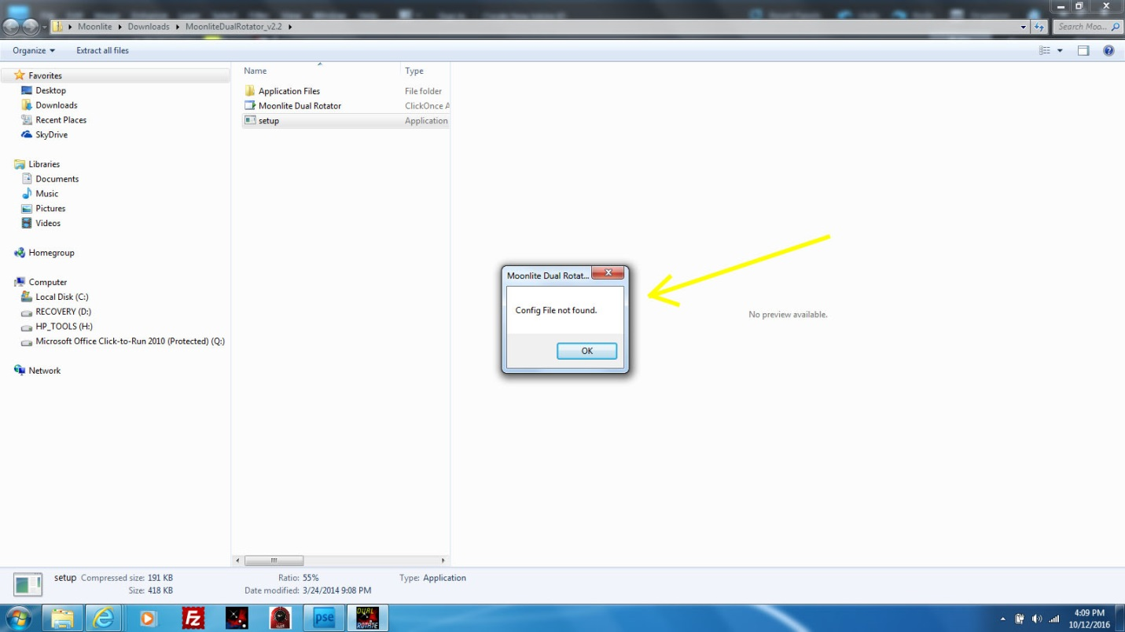

This error can come up as well when first trying to run the software with no connection to the USB port. It will go away once the USB connection is made the first time.

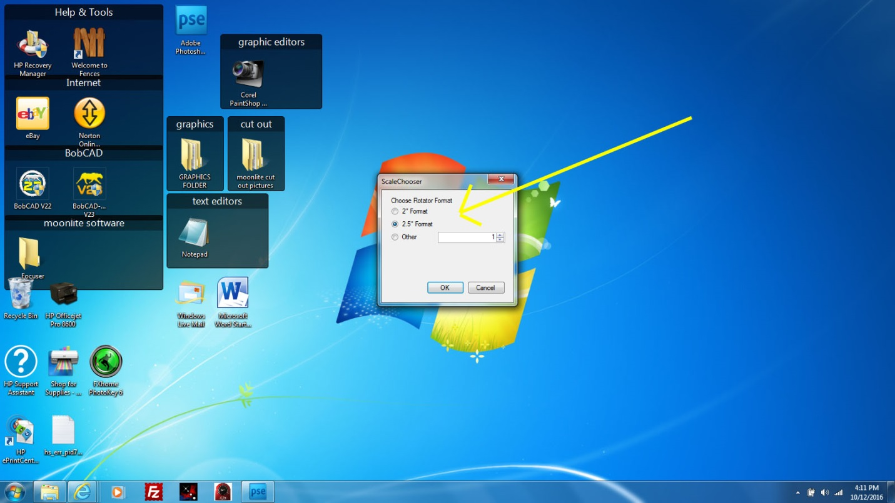

Pick the format size of the rotator and the program will start up.

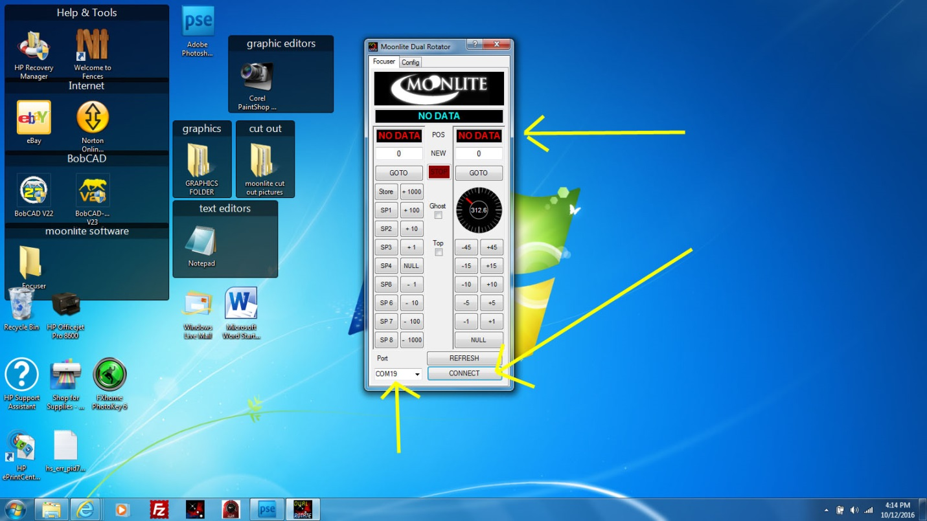

Click Connect on the bottom right. Note: the Com Port Windows assigned to the USB port.

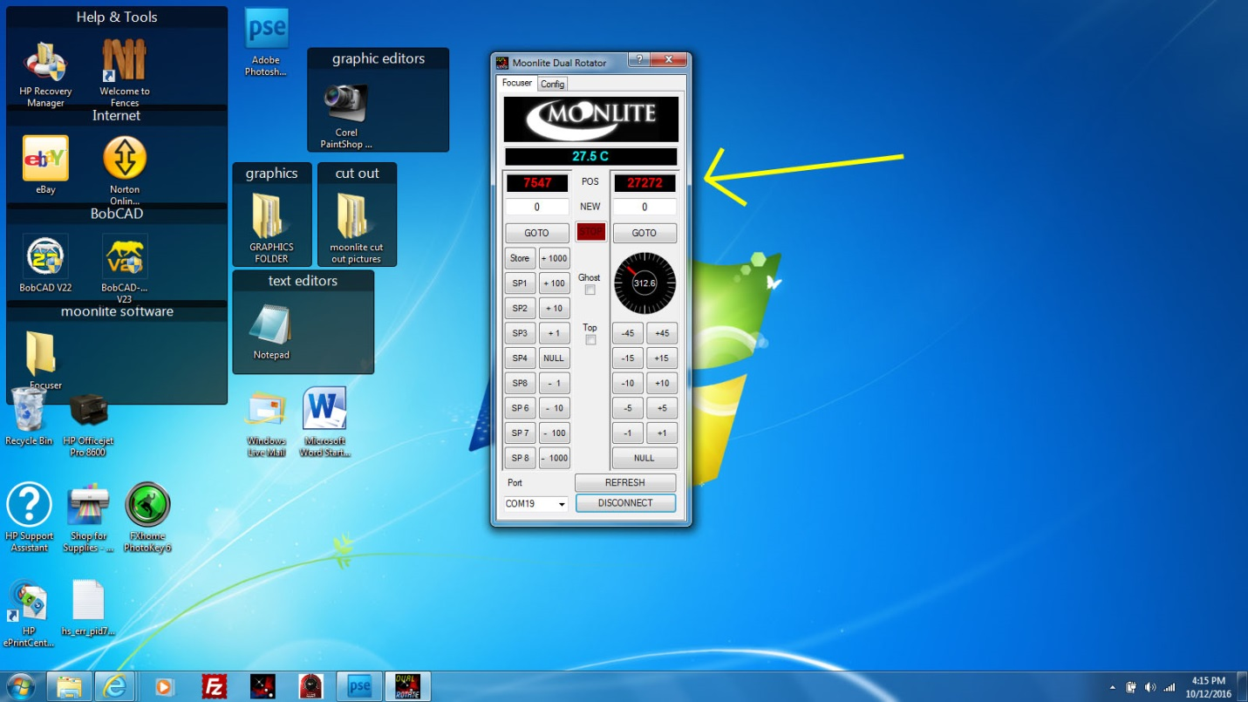

Once connected, the data fields will display the correct positions and you can now operate the focuser.

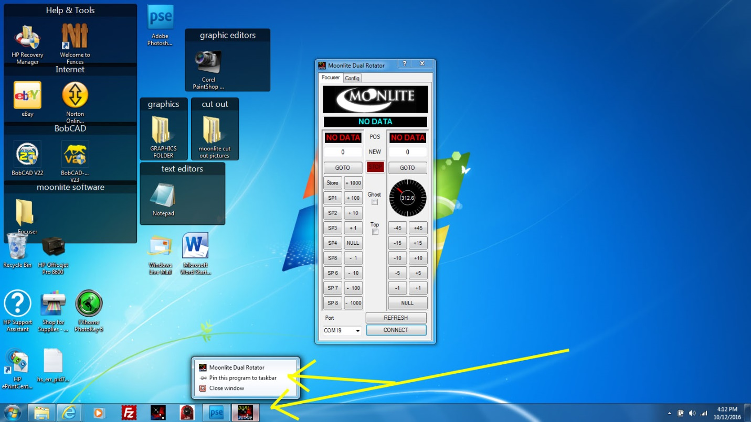

Pin the application so you have a nice shortcut to click on to run the program.

MoonLite Software and Driver Troubleshooting Guide

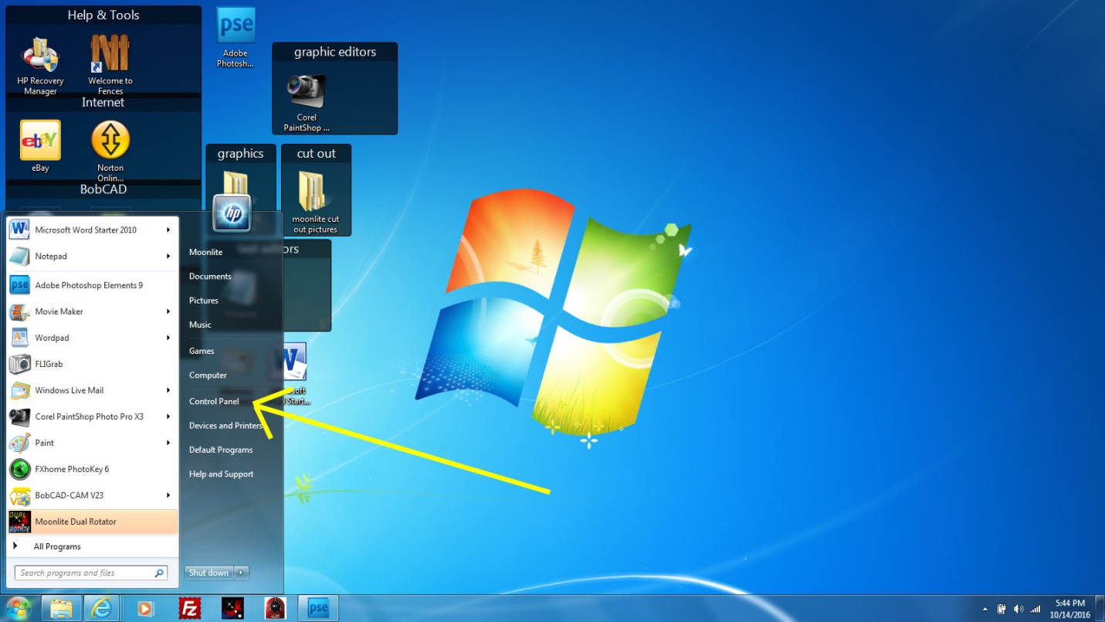

Verify that the USB FDTIChip driver is installed and working. Click on Control Panel.

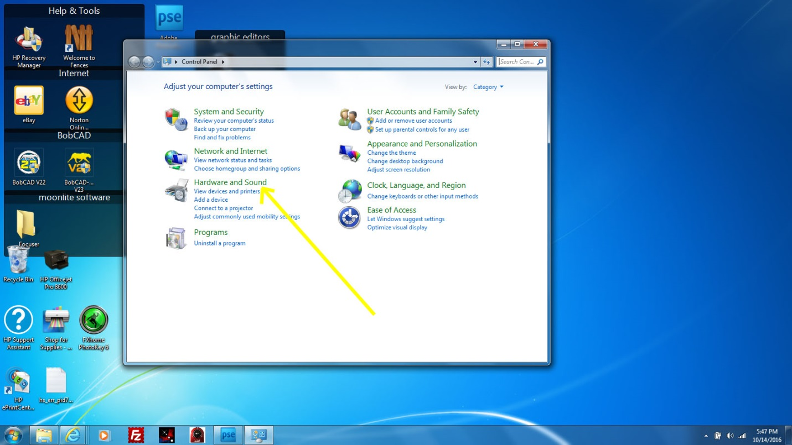

Click on Hardware and Sound.

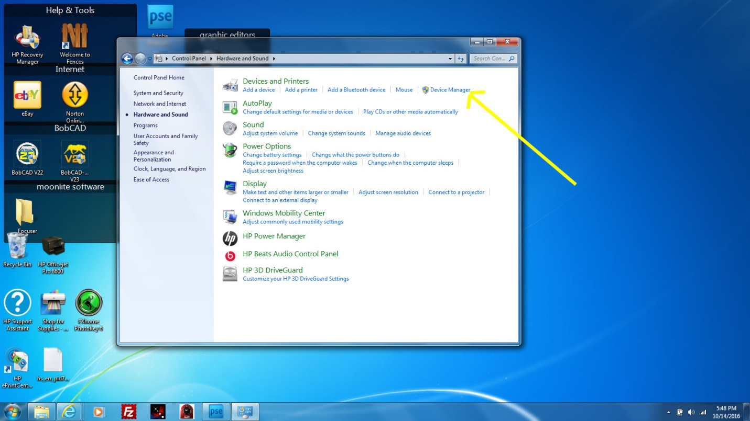

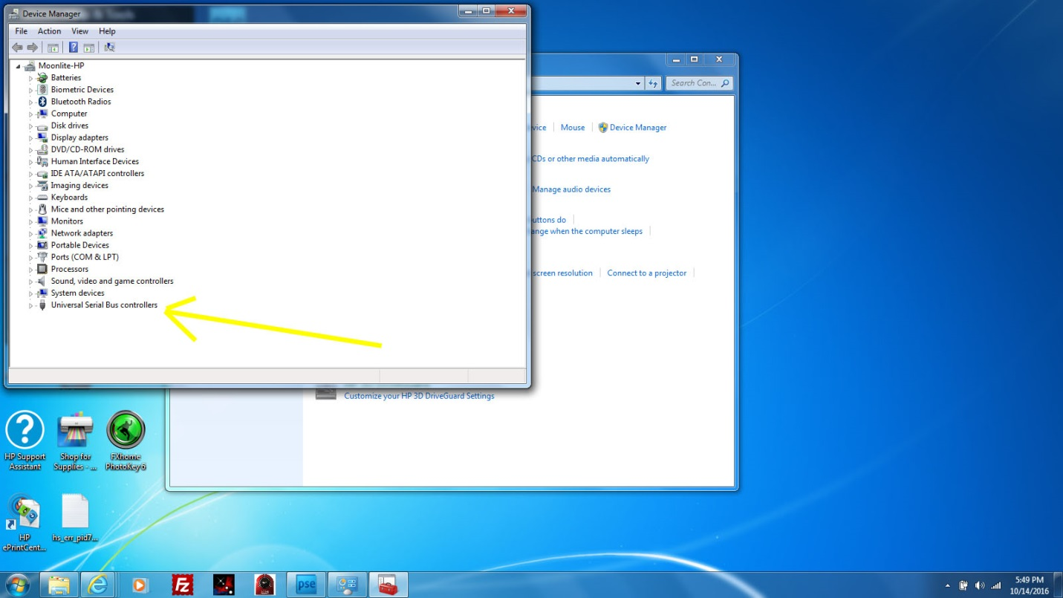Click on Device Manager.

Click on Universal Serial Bus controller.

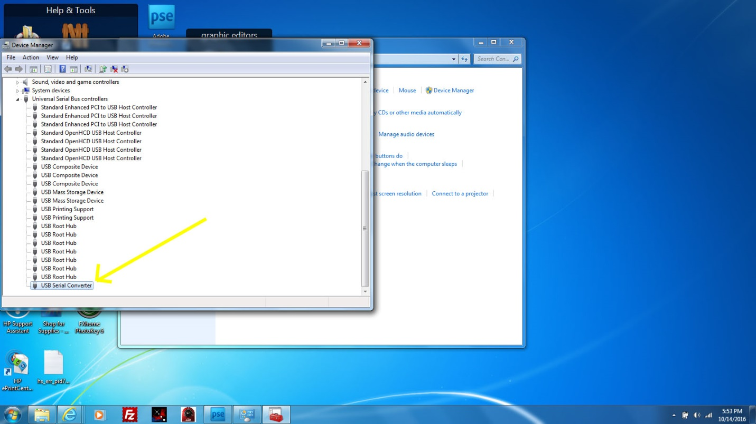

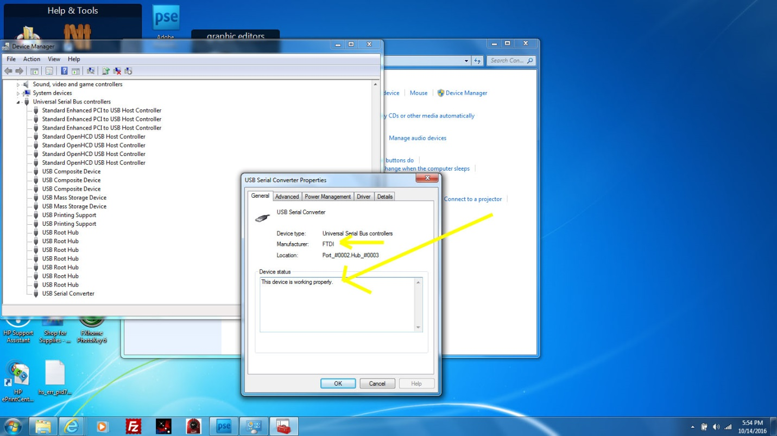Click on USB Serial controller.

Should show the FTDI driver is installed and working properly.

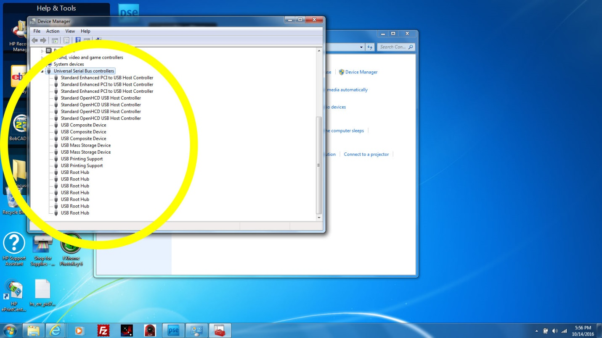Note: If the driver is not shown - Check the following: the driver installation, power to the controller, USB cable is connected to the controller. If the USB driver is not working you may see the warning message below (note that Windows did not assign a Com Port to the controller).

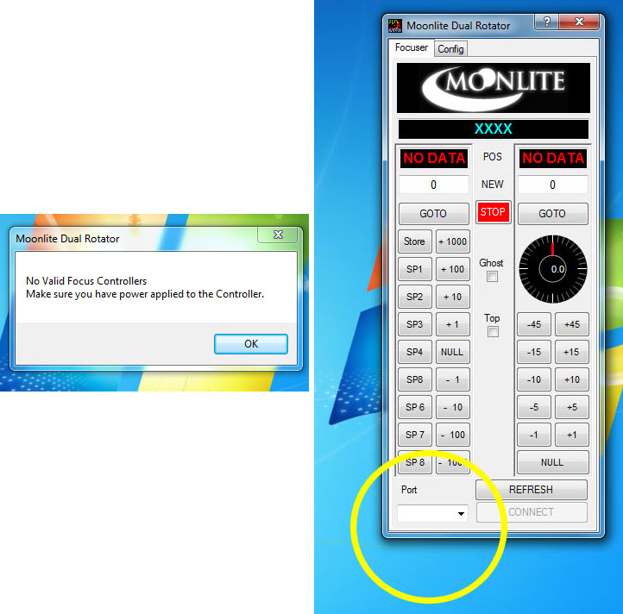

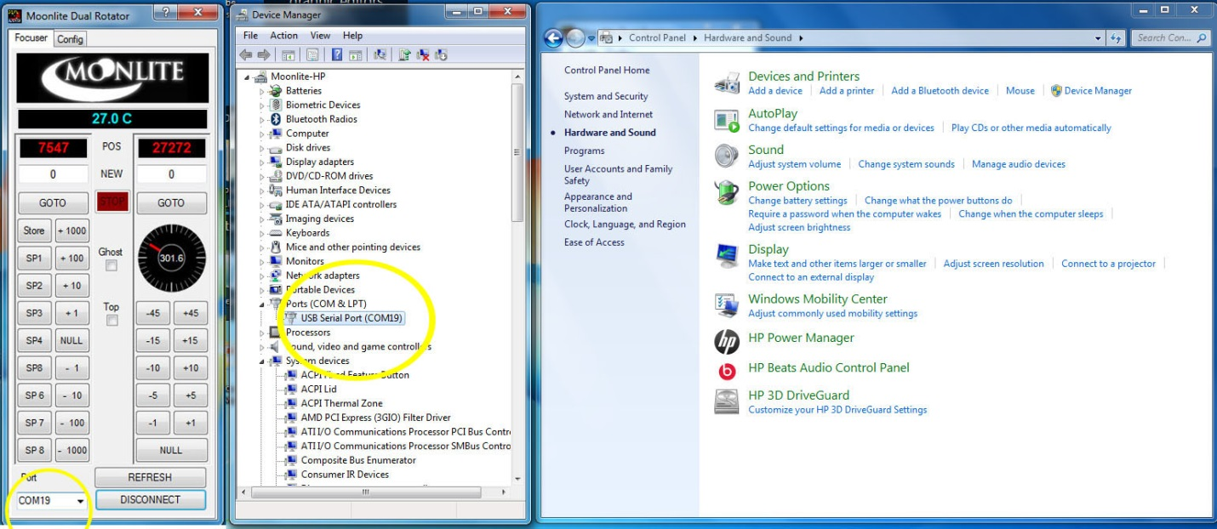

Here is how Device Manager lists the Com Port of the MoonLite controller when everything is working correctly.

**Moonlite ASCOM driver Installation guide**

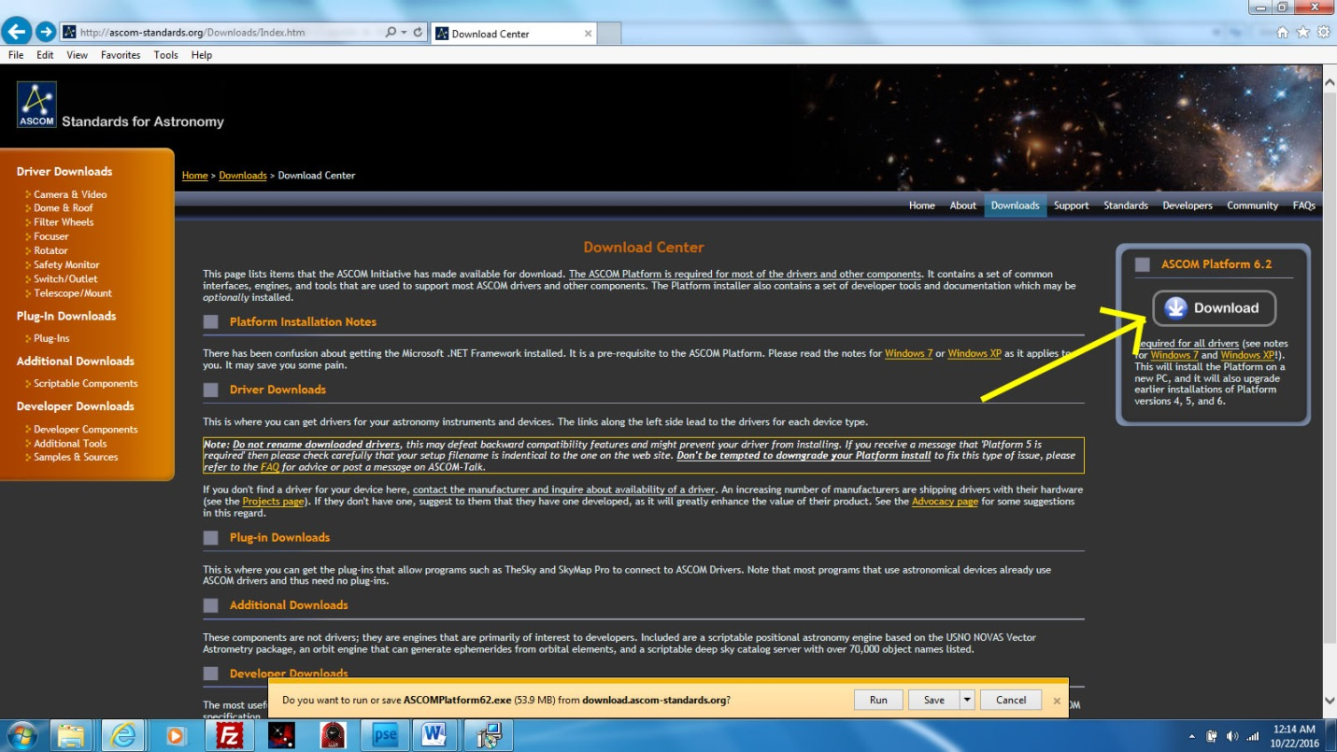

Make sure you have the lastest version of ASCOM platform installed before installing the Moonlite ASCOM driver.

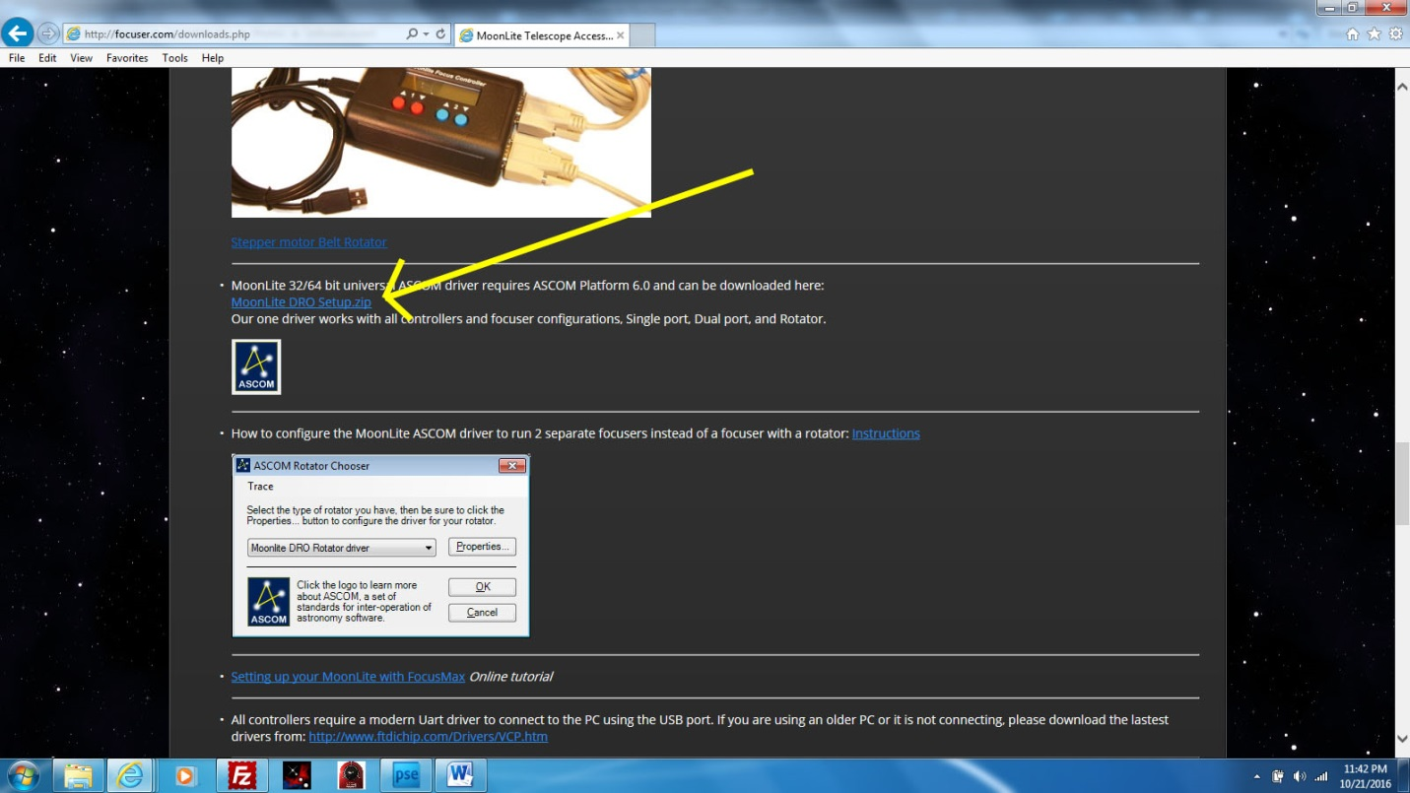

Go to the down load tab on the Moonlite page and click on Moonlite DRO Setup.

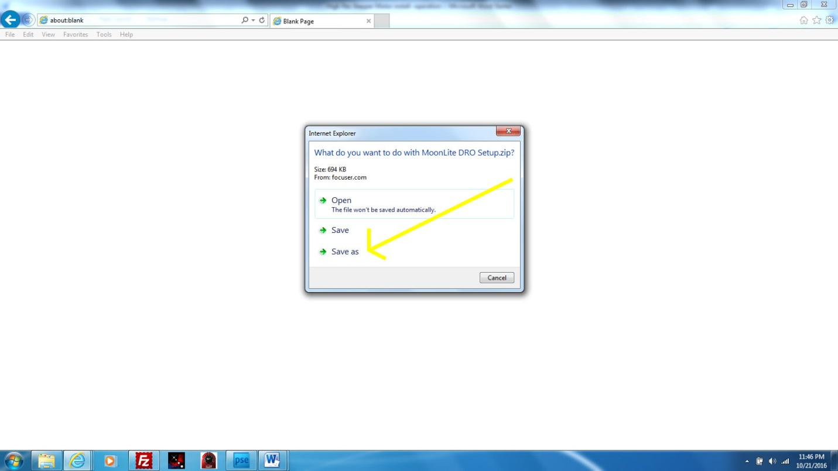

Click Save as.

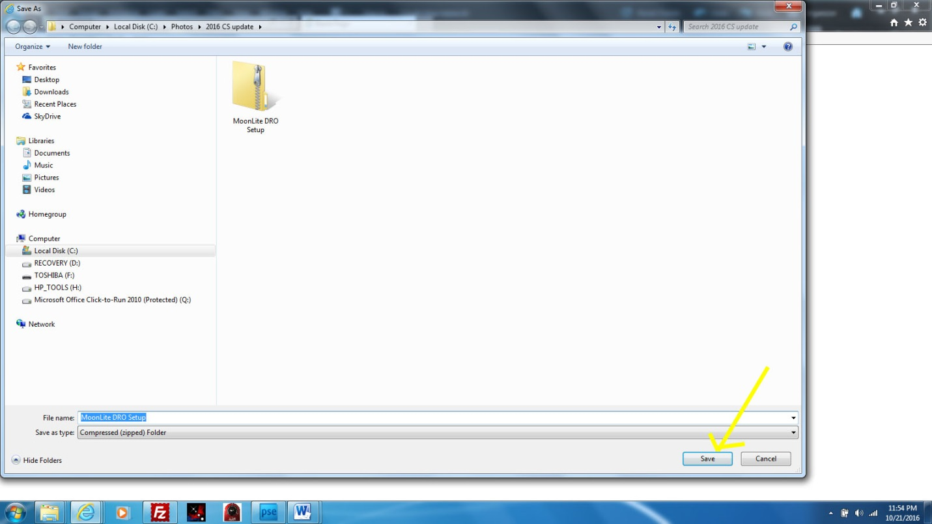

Note the directory it will go to and click Save.

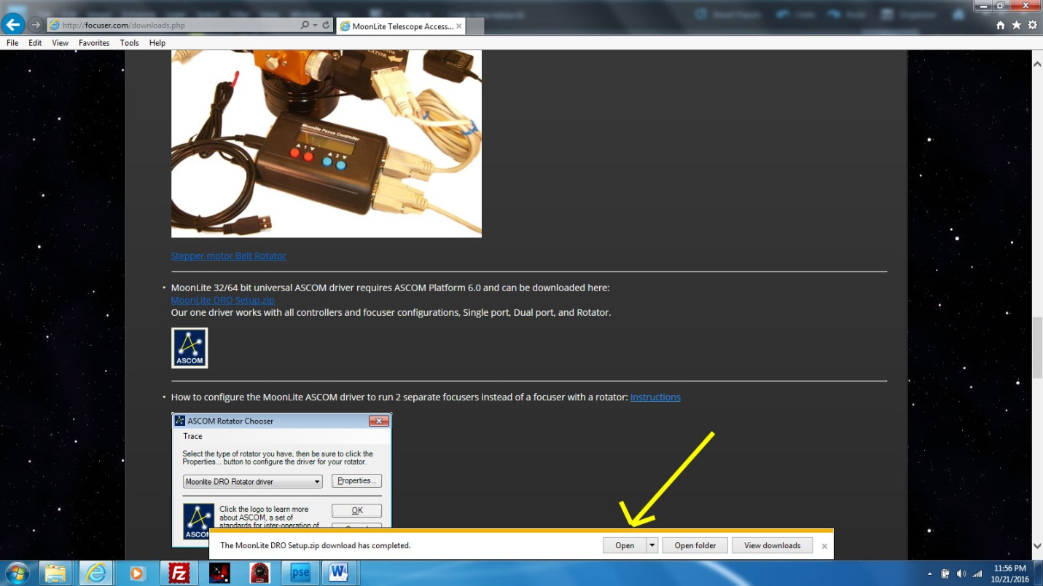

Click Open.

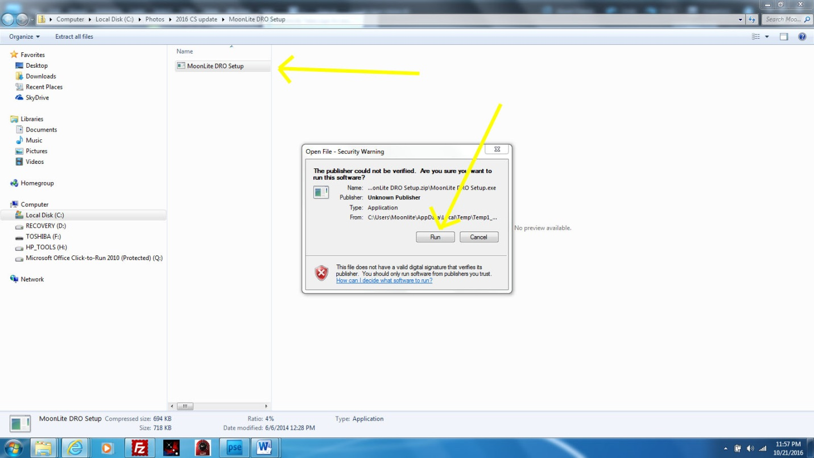

Click on DRO Setup then Run.

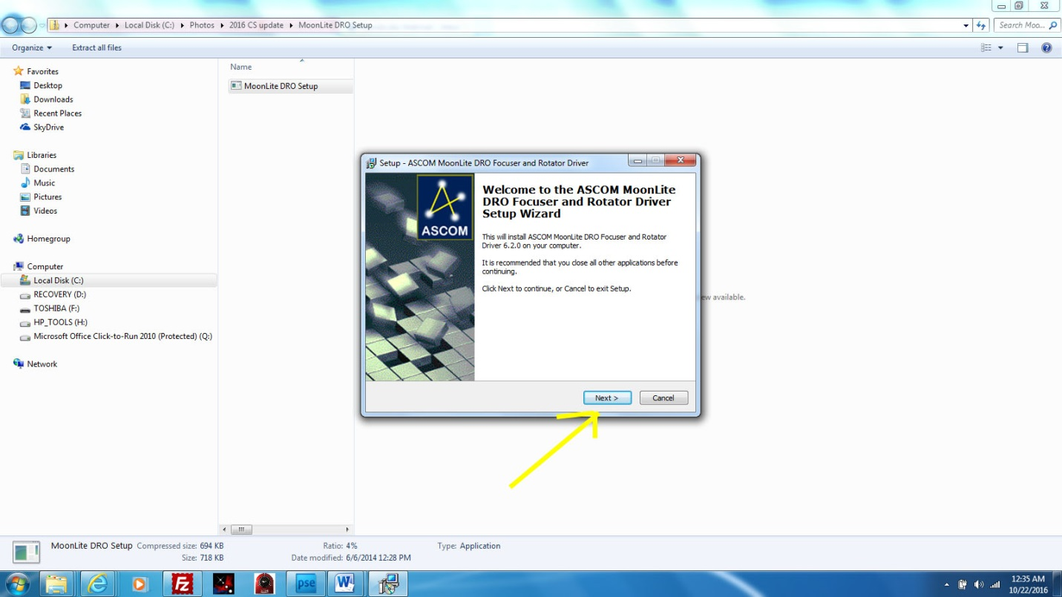

Click Next.

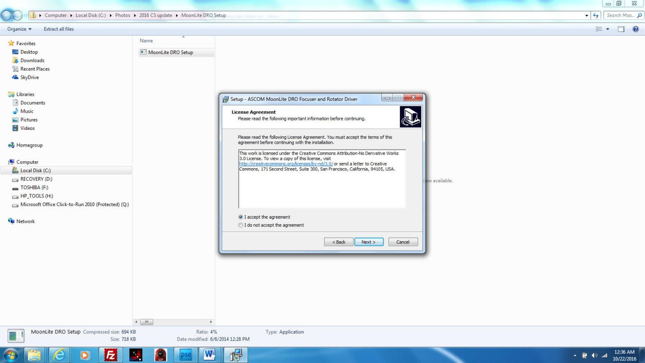

Click accept then Next.

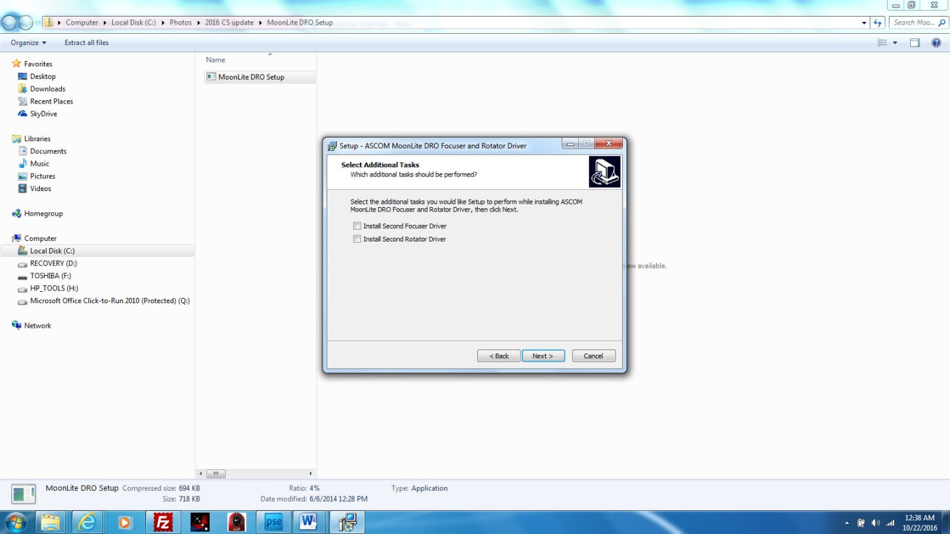

Click on Install 2nd rotator driver if you are installing a rotator on the 2nd port, or click 2nd focuser if you want to run 2 separate focusers.

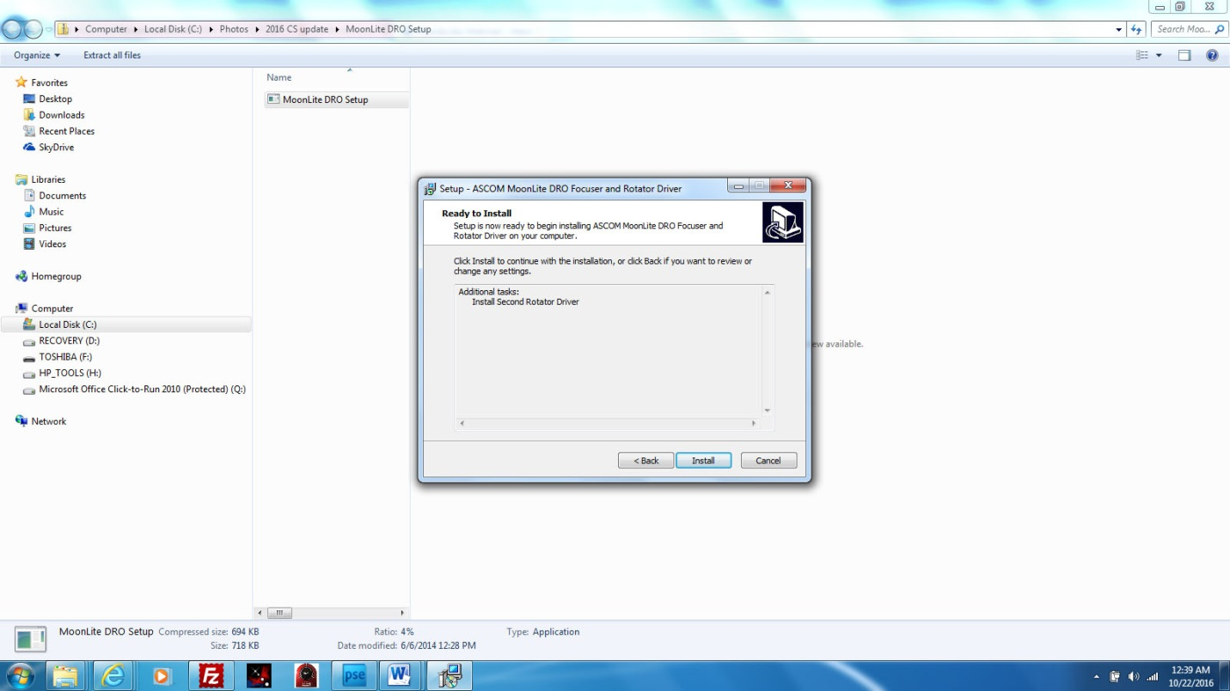

Click Install.

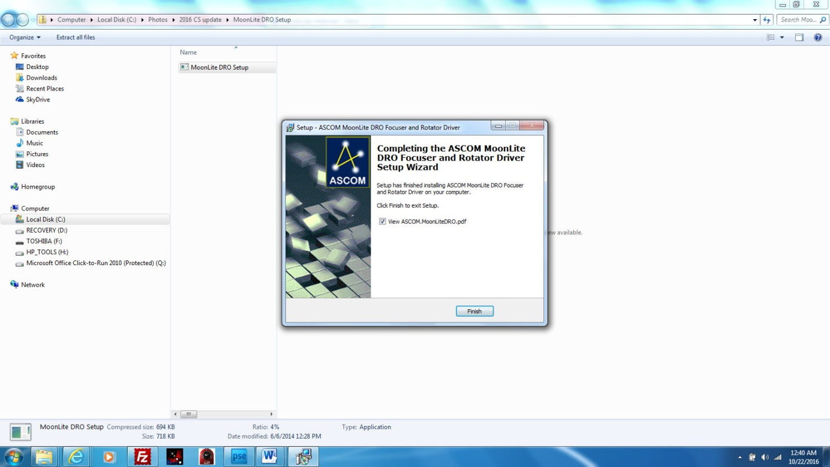

Click Finish.

**Information on ASCOM driver and hardware notes.**

ASCOM Driver for MoonLite Focusers and Rotators

Introduction

This Driver is designed to control the MoonLite Stepper motor controlled focusers and rotators

using either the new DRO controller or the original controller.

Requirements

• ASCOM Platform 6.0 or better, this is available from The ASCOM Downloads site.

• The .NET framework version 3.5, this is available from Microsoft, you can download it

from here. ASCOM requires this so it should already be installed.

Installation

Run the install program. This will install and register the driver. You can choose to install a second

focuser or rotator driver by checking the "Install Second Focuser Driver" or "Install Second Rotator

Driver" checkboxes.

Operation

• Select the appropriate driver by choosing the MoonLite DRO Focuser or MoonLite

DRO Rotator option in the chooser.

• A second focuser and rotator driver is available, this can be selected by choosing the

Second MoonLite DRO Focuser or Second MoonLite DRO 2 Rotator options

in the chooser. The details for this second device (COM port, DRO port, and so on) are

remembered separately.

• Select the Properties button to show the Setup Dialog. This will search for controllers

and display the controllers found. Those that have been set up are shown with the

current settings. The setup display is slightly different if setting up a rotator or focuser.

• Check the device you wish to use. The full details are shown below.

• Set the device type if necessary Port 1 will be set to be a Focuser and Port 2 a Rotator,

this can be changed if necessary. Take care to set this correctly, the driver cannot tell

which type of device it is connected to.

· Set the full details in the box underneath:

• The Name is set to help you to identify the device and will be reported as part of the name

property for the device.

• The Speed and Half/Full steps values control the motor speed and the step resolution. In

most cases the speed can be set to the maximum and full steps used. A rotator will only use

full steps.

• The Max Value can be set for a focuser; the focuser will be capable of moving between 0

and this value.

• The Rotator Type and Steps per Degree allow the rotator to be calibrated. The type

can be 2", 2.5" or User Defined. The Steps Per degree can be set if the type is user defined.

• The Temperature Coefficient can be set for focusers. This specifies the number of steps

the focuser will move for each deg C change in temperature. The range is from -128 to +127

steps per degree.

• If the Set Position checkbox is checked then the device position is set when the device

next connects. This is in steps for a focuser and in degrees for a rotator.

• If Full Temperature Compensation is checked then the position reported and used by

the driver is compensated for temperature using the current temperature coefficient. This

means that when temperature compensation is on the actual position of the focuser shown on

the control box will change as the temperature changes but the reported position will not.

This should mean that the same position will give the same focus at different temperatures.

• If Trace on is checked details of the commands sent to the hardware will be recorded in a

file. This file is in the My Documents\ASCOM\Logs<date> folder. <date> is the date in

the form 2013-06-20. Each file is called ASCOM.Moonlite.<time>.<number>.txt where

time is the time, e.g. 1823. These files may be useful in diagnosing problems.

Click on OK to save the values.

You can then connect using any focuser or rotator control application that supports the ASCOM

protocol.

The focuser and rotator can be controlled by one application or by two independent applications.

You can also connect more than one application to each device.

The focuser and rotator properties are remembered so you don't need to set them every time you

connect, as long as your application remembers the driver ID.

Notes

Focuser:

· The Step Size is reported as 4.14 microns per step for full steps and 2.07 for half steps.

Rotator:

• The hardware rotator positions are from -180 deg to +180 deg. The ASCOM specification is

that the focuser angle is in the range 0 to 360 degrees. The ASCOM positions have been

mapped to the hardware positions by adding 180 degrees to the hardware position.

• The ASCOM Reverse property reverses the direction of the rotator positions so the -180

hardware position corresponds to 360 degrees and the +180 hardware position corresponds

to 0 degrees in the ASCOM driver. This is done so that the user can set the reverse property

and get the rotation angle reported by the ASCOM driver to be in the correct direction

regardless of the optical configuration of the scope and imaging system.

Other:

• The Help button will display these instructions.

• These drivers will also work with the original MoonLite controller boxes.

• The drivers will operate with both 32 and 64 bit versions of Windows and with both 32 and

64 bit applications.

• The temperature is determined by reading the value every 2 seconds and averaging the last

30 values. This average value is returned. If less than 60 seconds have elapsed then the value

is the average of the number of samples read to date.

• The device is remembered by the COM port and DRO port the motor is connected to.

Chris Rowland 22 June 2013

**The SKYX Pro configuration**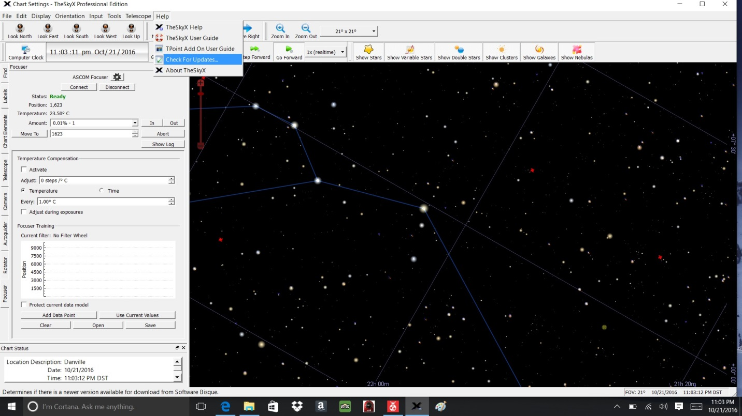

Update your SKYX Pro software to have the latest software support for Moonlite focusers.

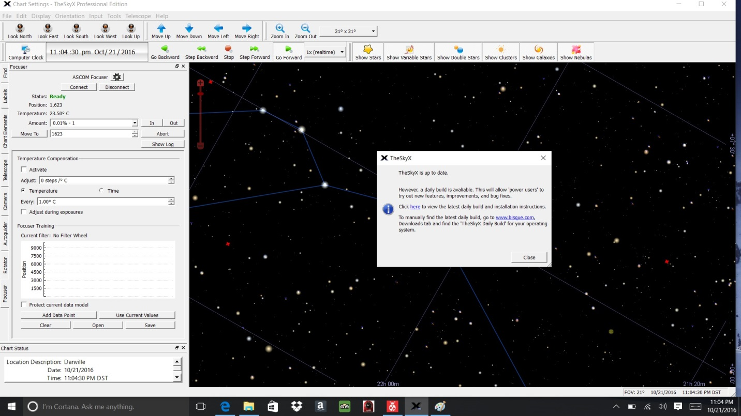

Click on Daily Build to load the Direct plug in support for MoonLite focusers.

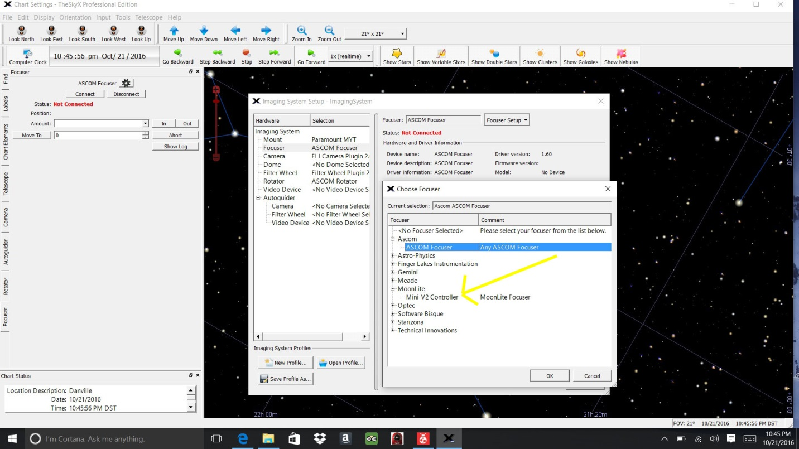

Pick Mini V2 controller if you are using that controller. No ASCOM is needed.

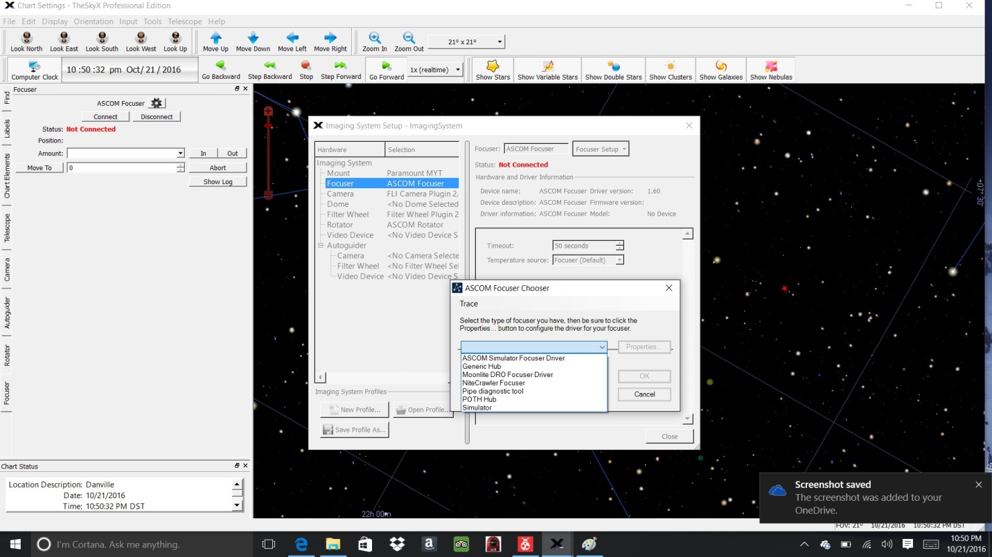

Pick Moonlite Dual Port DRO controller for the ASCOM focuser seection.

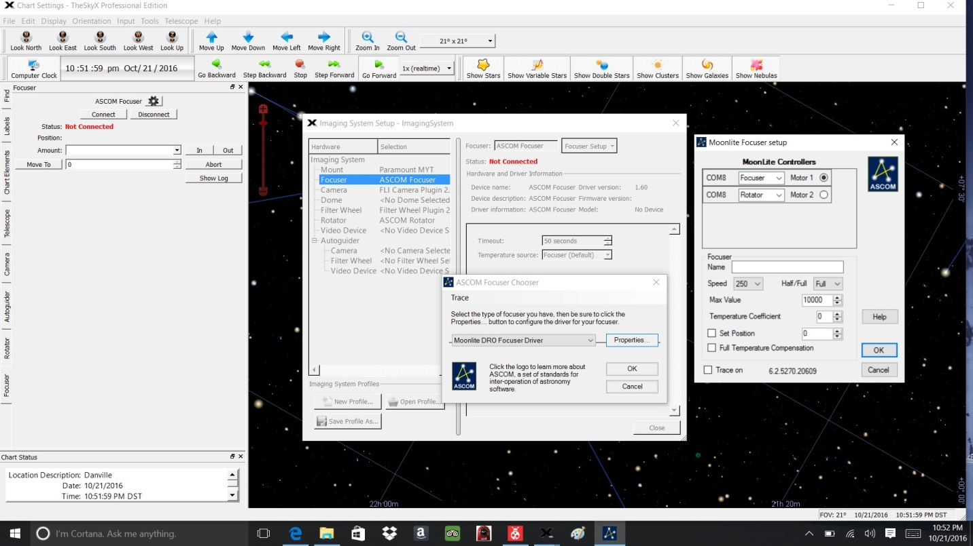

Pick the Moonlite Dual Port controller Properties box. Note MAX Step value should be set to a value equal to the travel of your drawtube. Example a 4.5” travel drawtube would have ( .00016” per step/ or 6250 steps per inch X 4.5” = 28,125 steps max) Default is 10,000, please adjust it based on the drawtube you have in the Moonlite focuser.

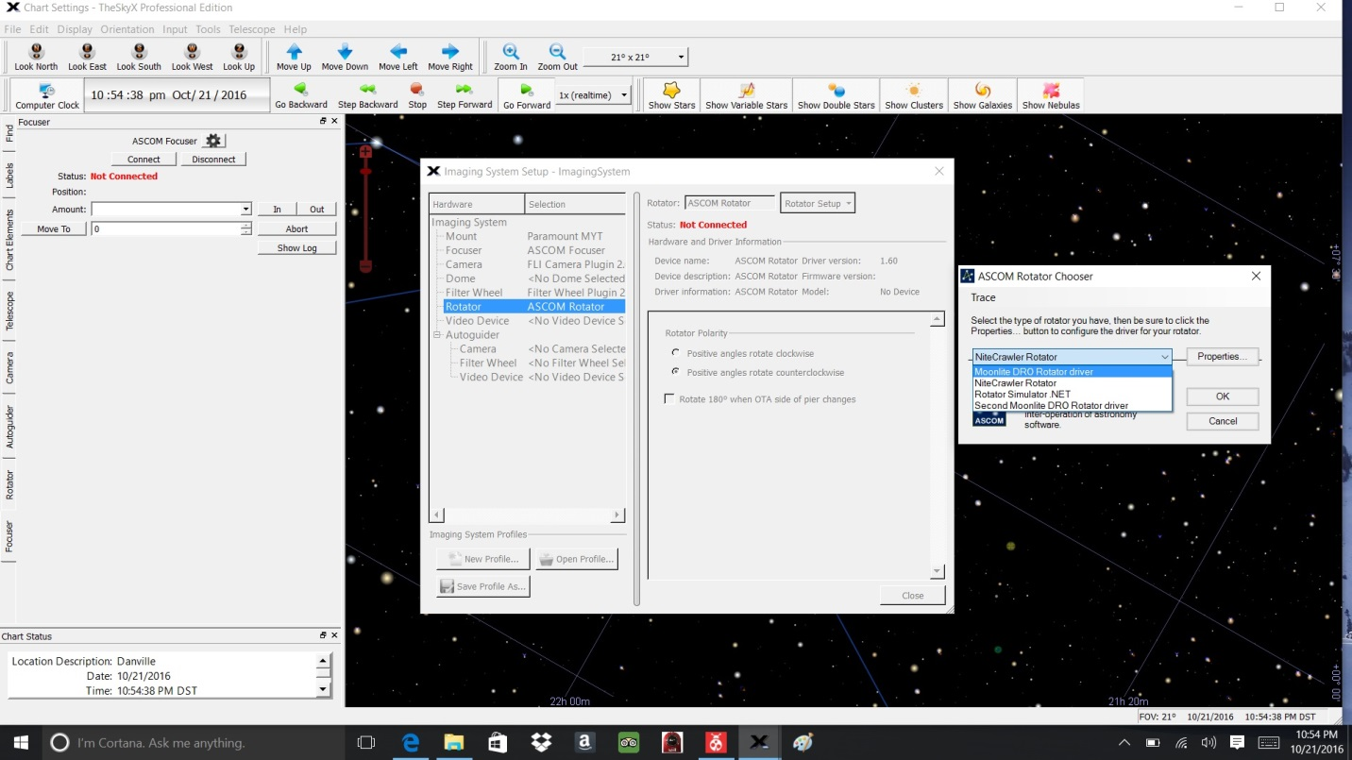

Under Rotator—Pick ASCOM rotator, then Moonlite DRO Rotator Driver

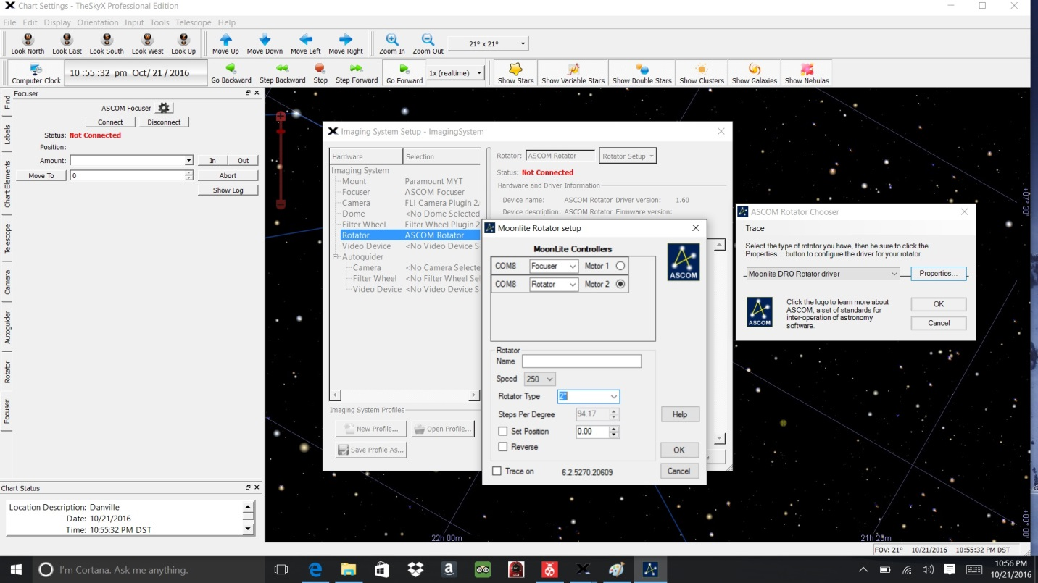

Pick Rotator size, 2” or 2.5” format.

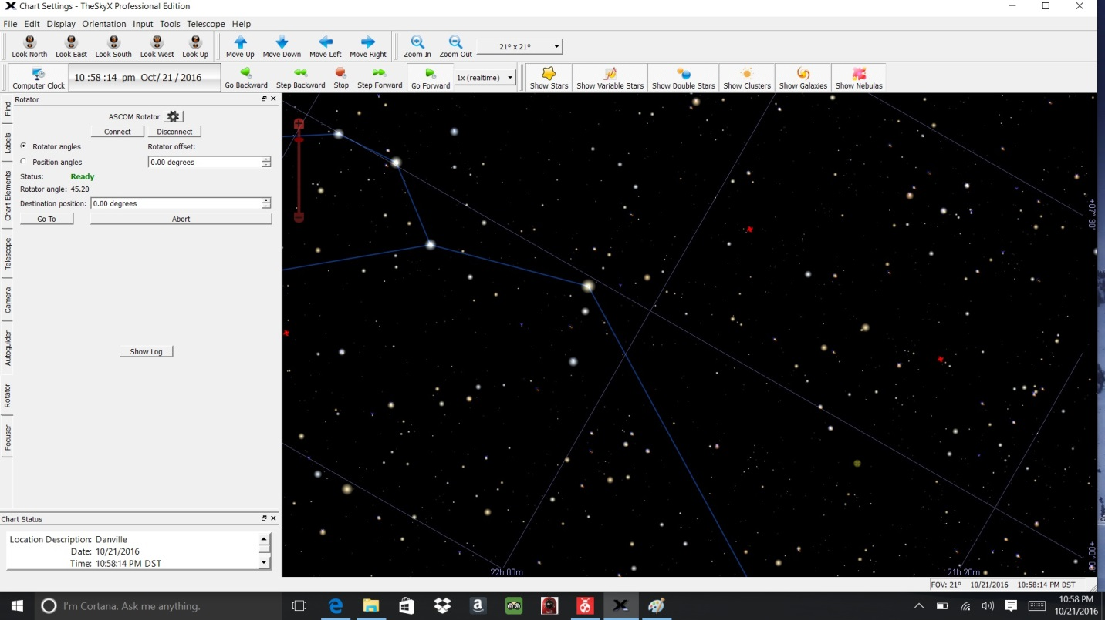

Click on left side focuser to operate rotation.

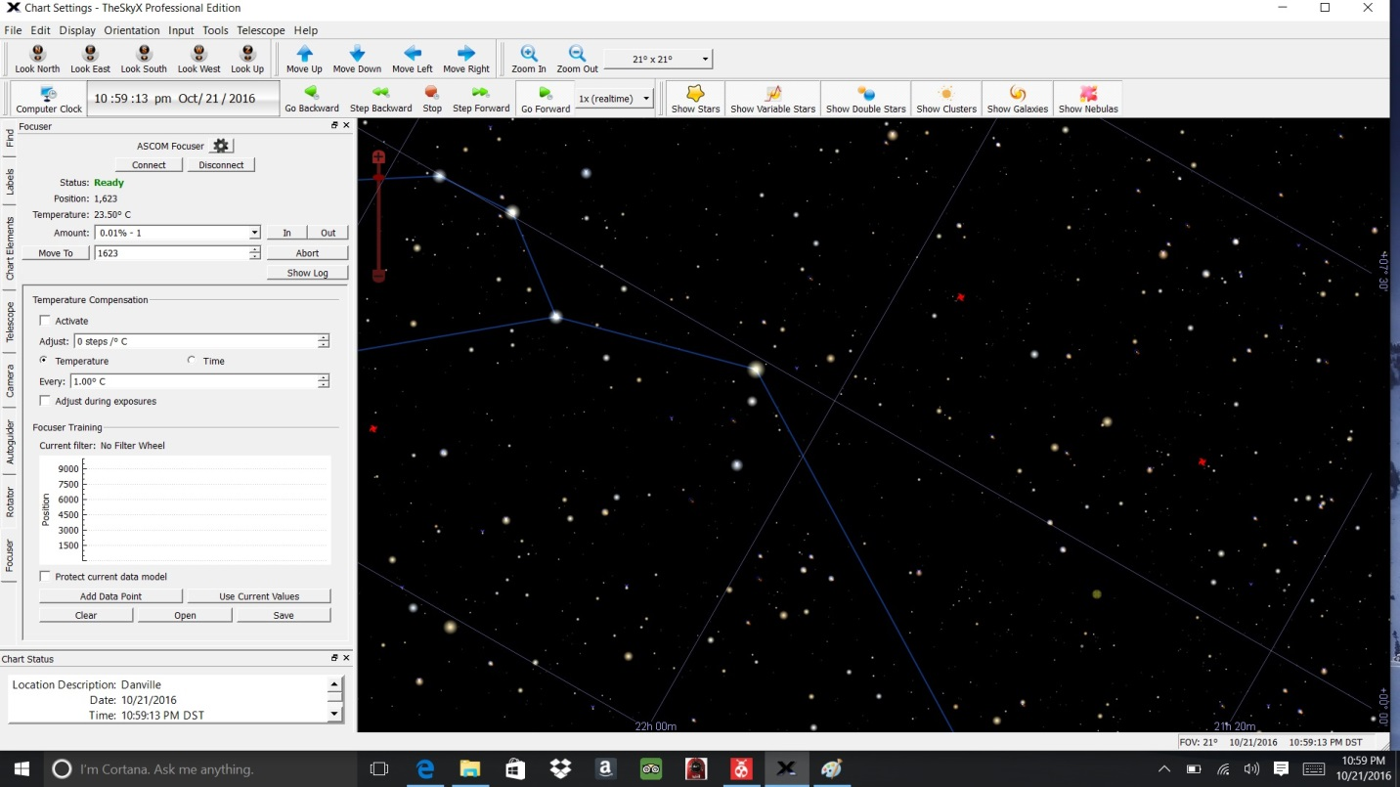

Click on Left side focuser to operate the focuser.

**MoonLite Telescope**

**www.focuser.com**